**DAILY ONLINE ACTIVITIES SUMMARY**

|  |  |  |  |  |  |  |  |  |
| --- | --- | --- | --- | --- | --- | --- | --- | --- |
| **Date:** | **6-06-2020** | | | | | **Name:** | **Kavya** | |
| **Sem & Sec** | **6th & A** | | | | | **USN:** | **4AL17CS041** | |
| **Online Test Summary** | | | | | | | | |
| **Subject** | | **Python (PAP)** | | | | | | |
| **Max. Marks** | | **30** | | **Score** | | | **27** | |
| **Certification Course Summary** | | | | | | | | |
| **Course** | **Python For Data science** | | | | | | | |
| **Certificate Provider** | | | **Udemy** | | **Duration** | | | **4 Hours** |
| **Coding Challenges** | | | | | | | | |
| **Problem Statement:1.** Program program to count number of strings  2. Write a Python program to perform Cyclic Redundancy Check  3. Write a program in C to rotate an array by N positions | | | | | | | | |
| **Status:Yes,I have uploaded all the programs** | | | | | | | | |
| **Uploaded the report in Github** | | | | | **Yes** | | | |
| **If yes Repository name** | | | | | [**https://github.com/kavya-077/DAILY-STATUS**](https://github.com/kavya-077/DAILY-STATUS) | | | |
| **Uploaded the report in slack** | | | | | **Yes** | | | |

Online Test Details: (Attach the snapshot and briefly write the report for the same)

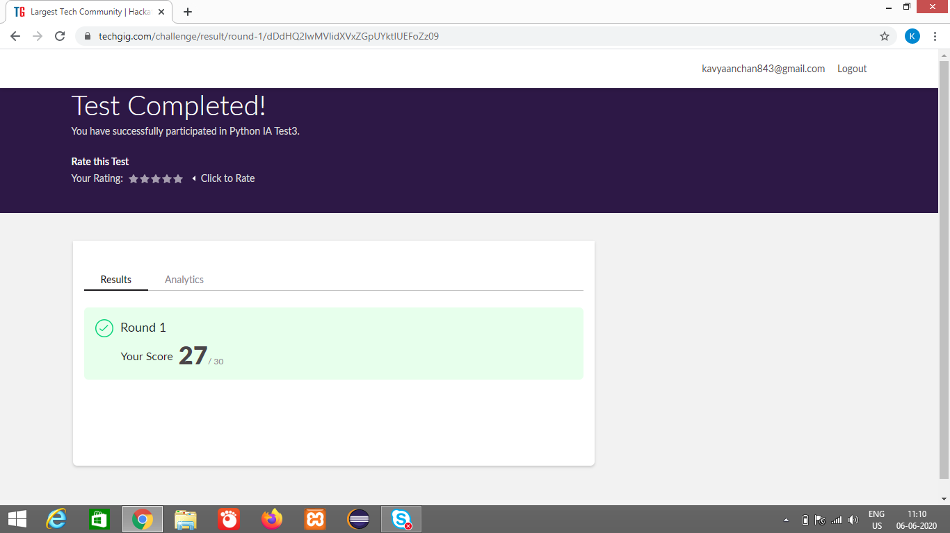

Certification Course Details: (Attach the snapshot and briefly write the report for the same)

PYTHON FOR DATA SCIENCE

This course specifically created for Data Science / AI / ML / DL. It covers BASICS PYTHON ONLY

**What we’ll learn**

* Acquire the prerequisite Python skills to move into specific branches - Data Science(Machine Learning/Deep Learning) , Big Data , Automation Testing, Web development etc..
* Have the skills and understanding of Python to confidently apply for Python programming jobs.

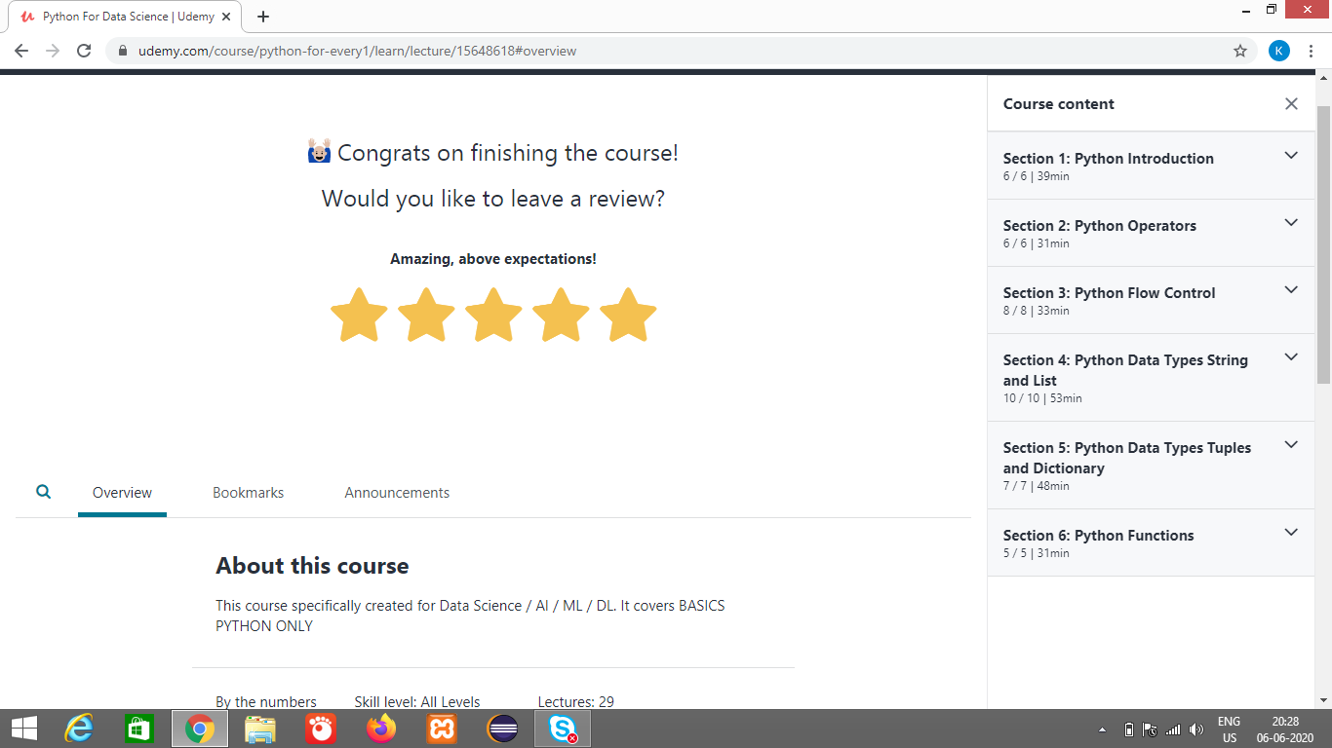

<https://github.com/kavya-077/DAILY-STATUS>

<https://github.com/alvas-education-foundation/kavya-onlinecourse>

Coding Challenges Details: (Attach the snapshot and briefly write the report for the same)

<https://github.com/kavya-077/DAILY-STATUS>

<https://github.com/alvas-education-foundation/kavya-OCA>